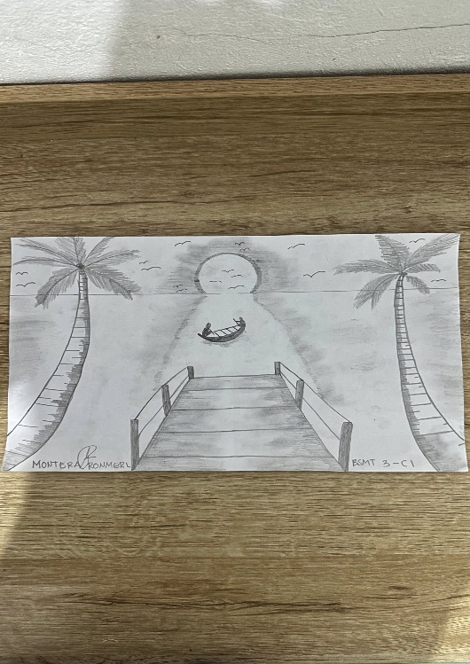
Title: Sunset by the Shore

Medium: Pencil on paper
Process:
Used linear perspective for depth (pier) and shading to separate water, sky, and land. Details like palm textures, ripples, and birds add realism and atmosphere.

Meaning:
A calm coastal scene showing peace and reflection. The boat suggests companionship or a quiet journey, while the pier connects land and sea.

Reflection:
Shows how simple shading and perspective can create emotion and a peaceful mood.

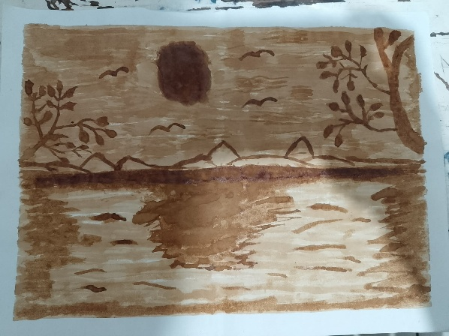
Title: Serenity at Sunset
Medium: Coffee on paper
Process:
Layered brewed coffee to create light and dark tones. Lighter washes for sky/water, darker for trees and details.
Meaning:
Represents peace and reflection in nature. The warm coffee tones give a nostalgic, calm feeling.
Reflection:
Learned to control contrast using limited tones and gained patience through the process.

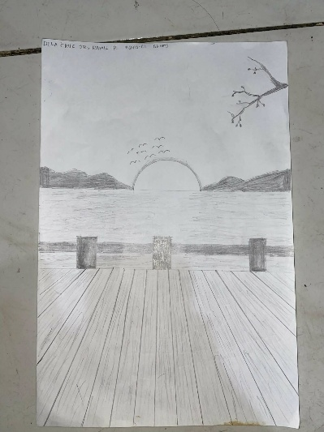
Title:
Sunset by the Pier

Medium/Material Used:
Pencil and paper
Short Description of Process:
I lightly sketched the main elements, then added perspective lines for the pier and refined the details. I used shading to create depth, making the foreground darker and the background softer.
Meaning/Interpretation:
The drawing represents peace and quiet reflection during a sunset. It symbolizes endings, calmness, and taking time to appreciate nature.
Brief Reflection :
I learned how perspective and shading help make a drawing look more realistic. I also experienced patience and felt relaxed while working on the piece.

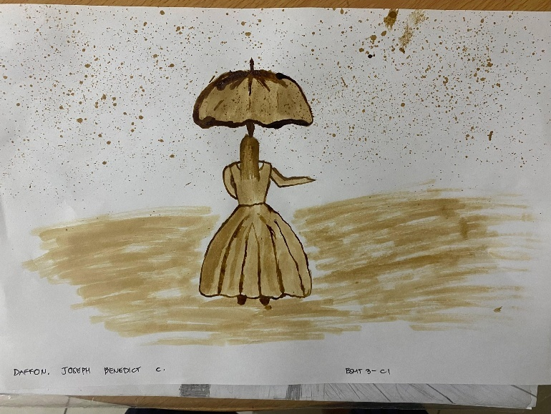

Title: The Girl in the Rain

Medium: Coffee, paper, brush, pencil
Process:
Sketched the figure and umbrella, then used light and dark coffee tones. Splattered coffee to create a rain effect.
Meaning:
Shows calmness and independence despite challenges. The warm tones give a peaceful, nostalgic mood.
Reflection:
Learned to control coffee as a medium and saw how imperfections can enhance the artwork.

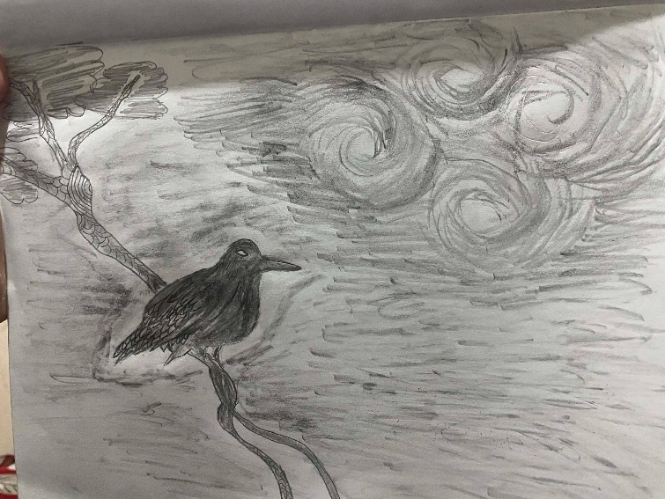

Title: Whispers of the Night

Medium: Graphite pencil on paper
Process:
Light sketch first, then added details and shading using different pressures and blending for smoothness.
Meaning:
Represents quiet emotions—calm on the outside but full of thoughts inside, shown by the bird and swirling sky.
Reflection:
Learned patience and how shading helps create depth, mood, and emotion.

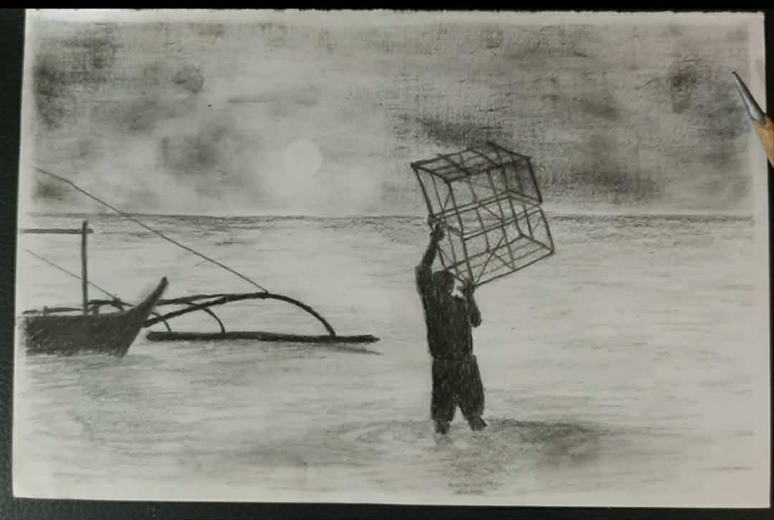

Title: Fisher Man
Medium: Pencil on paper
Process:
Used pencil shading and pressure control to create different tones, with clear outlines for the boat, figure, and cage.
Meaning:
Represents the hard and uncertain life of a fisherman, showing dedication and dependence on the sea.
Reflection:
A reminder of fishermen’s strength and courage in facing daily challenges and uncertainty.

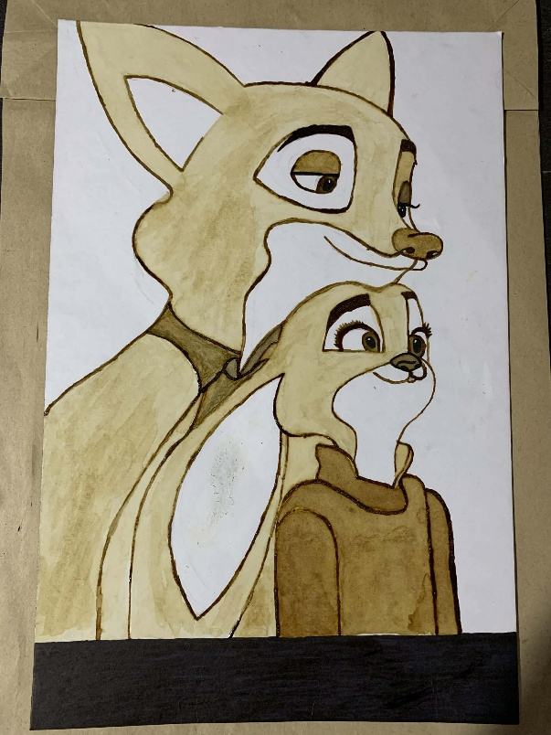

Title:
Gentle Bond shows a calm and emotional connection between two characters.
It reflects warmth and companionship through their close pose.

Medium / Materials Used:
This artwork is made using coffee as the main painting medium on paper.
A brush was used to apply different shades and details.

Short Description of Process:
Light coffee washes were applied first to build the base tones.
Darker layers were added for outlines, shading, and dept
Meaning / Interpretation:
The two characters represent trust, support, and closeness.
Their shared gaze suggests hope and looking forward together.

Brief Reflection:
I learned how to control shading using a single medium like coffee.
I also experienced how simple colors can still express strong emotions.

